AWS Database Migration Service

& AWS Schema Conversion Tool

Oracle to PostgreSQL – Lab Guide

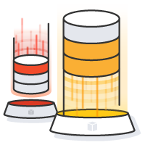

Steve Shirkey

Solutions Architect

shirkeys@amazon.com

RUN THIS WORKSHOP IN AP-NORTHEAST-1 (TOKYO)

# Objective

In this lab, you will be performing a migration from Oracle to PostgreSQL using SCT and DMS.

High Level Steps:

* Create a AWS CloudFormation stack
* Create AWS Database Migration Instances
* Connect to your environment
* Setup AWS Schema Conversion Tool
* Convert the Oracle schema to PostgreSQL
* Create Source Endpoint in AWS DMS
* Create Target Endpoint in AWS DMS
* Create a Migration Task in AWS DMS
* Start the migration
* Generate transactions on Oracle and see the data being migrated to PostgreSQL - CDC (Change Data Capture)



Prerequisites - Generate EC2 key pair

In this step, you will generate an EC2 key pair for use in the Database Migration Workshop labs.

Make sure you use your own AWS account and are in the right region (Tokyo: ap-notheast-1).

|  |
| --- |
| https://ap-northeast-1.console.aws.amazon.com/ec2/v2/home?region=ap-northeast-1#KeyPairs:sort=keyName |

1. Click ‘**Create Key Pair**’

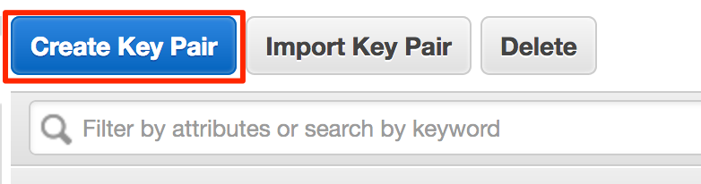

1. Name the key pair ‘**DMSKeyPair**’ and then click ‘**Create**’. At this point, your browser will download a file named ‘**DMSKeyPair.pem**’

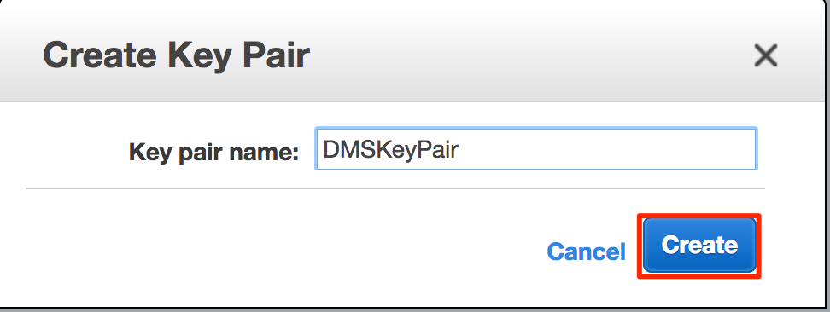

1. Download the private key file and store it locally

Prerequisites - Install a SQL Client

* Install a SQL client of your choice; in this lab – we will be using SQLWorkbenchJ screenshots
  + SQL WorkbenchJ: <http://www.sql-workbench.net/downloads.html> (download generic packages generic package for all systems or package for MacOS)
  + DBeaver: <http://dbeaver.jkiss.org/>
  + SQuirrel: <http://squirrel-sql.sourceforge.net/>

Download JDBC Drivers

* Download & keep this file locally
* You will need these to connect to source & target databases using SQL client & AWS Schema Conversation Tool

|  |
| --- |
| https://s3-ap-southeast-1.amazonaws.com/aws-apac-dms-workshop/content/labs/jdbc-drivers/ojdbc7.jar  https://s3-ap-southeast-1.amazonaws.com/aws-apac-dms-workshop/content/labs/jdbc-drivers/postgresql-42.1.1.jar |

Create AWS CloudFormation Stack

In this step, you will launch a AWS CloudFormation template they will setup the following resources needed for this lab.

* Source Database: Amazon RDS Oracle (this database will be pre-populated with sample database installed from <https://github.com/awslabs/aws-database-migration-samples>)
* Target Database: Amazon RDS PostgreSQL

## Instructions

* Open the link provided below

|  |
| --- |
| https://ap-northeast-1.console.aws.amazon.com/cloudformation/home?region=ap-northeast-1#/stacks/new?stackName=apac-tech-summit-dms-lab&templateURL=https://s3-ap-southeast-1.amazonaws.com/aws-apac-dms-workshop/content/labs/cloudformation/apac-dms-workshop-cfn.template |

* Click Next

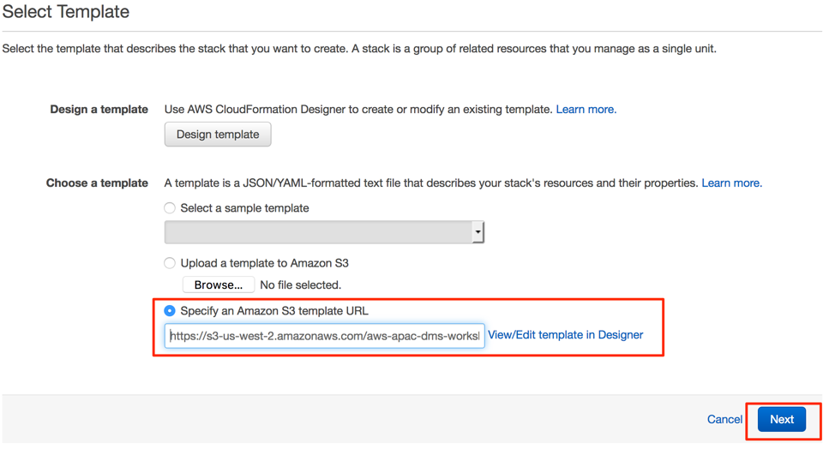

* Enter the following parameters in the ‘Specify Details’ page – *this should be populated by default*
  + Stack name: apac-techsummit-dms-lab
  + Source Oracle Database Configuration

|  |  |
| --- | --- |
| OracleDBName | ORCL |
| OracleDBPassword | oraadmin123 |
| OracleDBStorage | 100 |
| OracleInstanceType | db.t2.medium |

* + Target RDS PostgreSQL Database Configuration

|  |  |
| --- | --- |
| RDSDBName | postgres |
| RDSDBUsername | postadmin |
| RDSDBPassword | postadmin123 |
| RDSInstanceType | db.t2.medium |
| RDSDBStorage | 100 |

* + Click Next

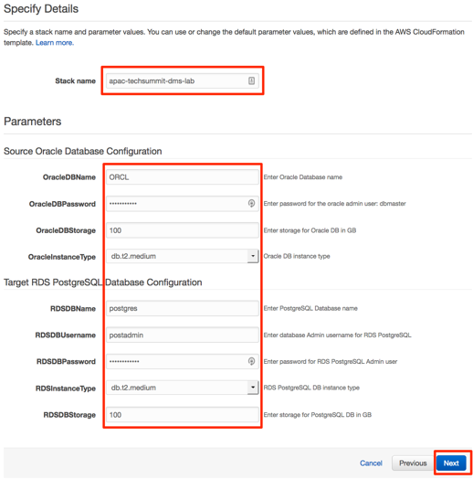

* Tags

|  |  |
| --- | --- |
| Key | purpose |
| Value | techsummit-dms-lab |

* + Click ‘**Next**’

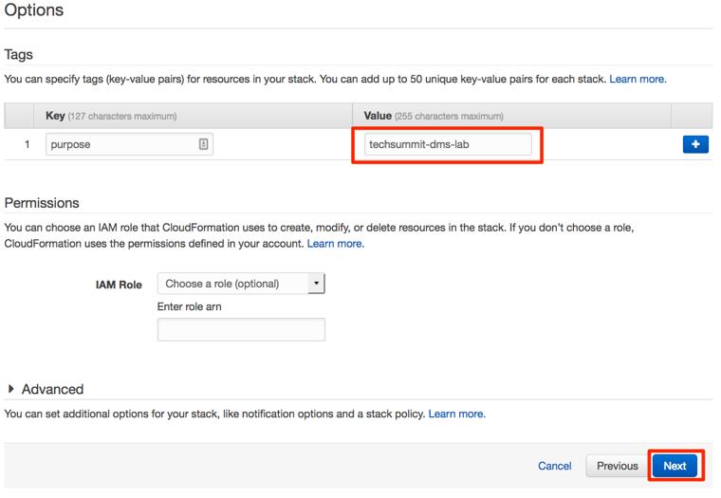

* Review and Click Create

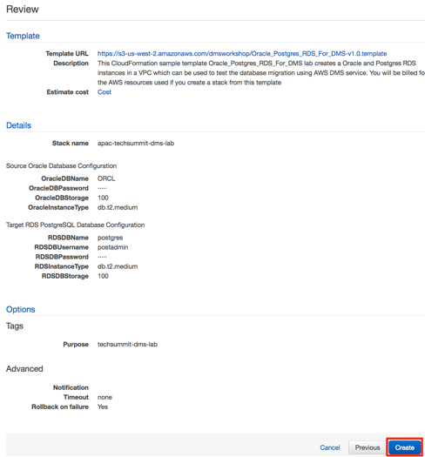

* Confirm that you have one Oracle RDS instance and PostgreSQL RDS instance in the Tokyo region. You need RDS instance Endpoints information in the next AWS SCT project set up stage.

AWS Schema Conversion Tool

# Install AWS Schema Conversion Tool (on your laptop)

* Download the latest version of AWS Schema Conversion Tool (SCT) from this link <http://docs.aws.amazon.com/SchemaConversionTool/latest/userguide/CHAP_SchemaConversionTool.Installing.html>
* If you already have SCT installed, update or download the latest version & install it. To check whether new version of AWS SCT is available, choose **Help**, and then choose **Check for Updates**. If there is a newer version of AWS SCT available, you are prompted to download and install the newer version.
* JDBC Drivers
  + For connecting to our source (Oracle) vs target (PostgreSQL) you will need the respective JDBC drivers
    - Oracle JDBC driver: http://bit.ly/2phVpPk
    - PostgreSQL JDBC driver: http://bit.ly/2pt04ZT
* Configure SCT with drivers: After you have downloaded and installed the required JDBC drivers, you can set the location of the drivers globally in the AWS SCT settings. If you don't set the location of the drivers globally, the application asks you for the location of the drivers when you connect to a database.
  + Click on **Settings** > **Global Settings**

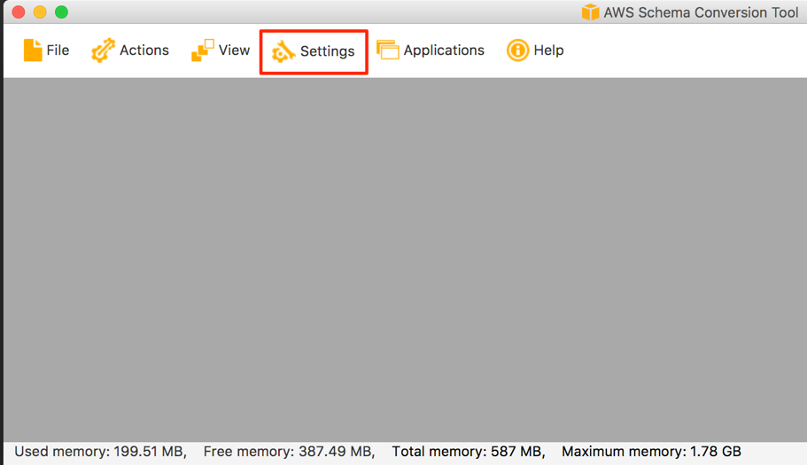

* + In the Global Settings window,
    - Choose **Drivers** on left panel
    - Oracle Driver Path: Select the downloaded ojdbc jar file
    - PostgreSQL Driver Path: Select the downloaded postgresql jar file
    - Click **OK** to Proceed

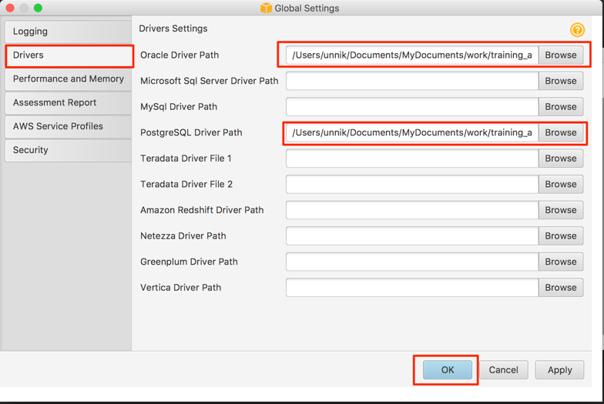

Open Security Groups from Source / Target Database Instances

For you to access Source and Target databases, you will have to add your laptop to Oracle & Postgres Security Groups.

|  |
| --- |
| https://ap-northeast-1.console.aws.amazon.com/ec2/v2/home?region=ap-northeast-1#SecurityGroups:sort=groupId |

Add following inbound rule to respective security groups:

* Select Group Name “XXXXX” -> Click Edit in the Inbound tab -> Add Rule: Type - Oracle-RDS, Protocol - TCP, Port Range - 1512, Source - My IP, Description - Source Oracle database inbound port
* Select Group Name “YYYYY” -> Click Edit in the Inbound tab -> Add Rule: Type - PostgreSQL, Protocol - TCP, Port Range - 5432, Source - My IP, Description - Target PostgreSQL database inbound port

Create a new SCT project

In this step, you will create a SCT project to connect your source Oracle database and target PostgreSQL database.

* Open your AWS Schema Conversion Tool in your local laptop, select File > New Project Wizard
* Step 1 - Create a new project

|  |  |
| --- | --- |
| Project Name | DMS-Workshop-Oracle2PostgreSQL |
| Location | Leave Default  Transactional Database (OLTP) |
| Source Database Engine | Oracle  I want to switch engine and optimize for the cloud |
| Target Database Engine | Amazon RDS for PostgreSQL |



* Click OK to proceed
* Step 2 – Connect to Source database. Click the “Connect to Oracle” in the console

|  |  |
| --- | --- |
| Type | SID |
| Server Name | DNS Endpoint of your Oracle RDS instance (check RDS console)  e.g. aovk0f0z2qfxxx.cilfwlyrnxxx.ap-northeast-1.rds.amazonaws.com |
| Server Port | 1521 |
| Oracle SID | ORCL |
| User name | dbmaster |
| Password | oraadmin123 |



* + Click ‘**Test Connection**’ – Make sure you get a ‘**Connection Successful**’ message



* + Click ‘**OK’** to proceed. You will get schemas from Oracle.



* Step 3 – Connect to Target. Click “Connect to Amazon RDS for PostgreSQL” in the console

|  |  |
| --- | --- |
| Server Name | DNS Endpoint of your PostgreSQL RDS instance (check RDS console)  e.g. aovk0f0z2qfxxx.cilfwlyrnxxx.ap-northeast-1.rds.amazonaws.com |
| Server port | 5432 |
| Database | postgres |
| User name | postadmin |
| Password | postadmin123 |



* + Click ‘**Test Connection**’ – Make sure you get a ‘**Connection Successful**’ message
  + Click ‘**OK**’ to proceed
* Step 4 – Confirm that you connected both source and target databases. Click the “View - Main View” in the console



Run Schema Conversation In SCT

In this step, you will generate a Database Migration Assessment report to verify required conversion effort between Oracle and PostgreSQL databases. Also, you will convert a “DMS_SAMPLE” schema in Oracle to PostgreSQL.

* Select only ‘DMS_SAMPLE’ schema on the left panel.
* Right click and select ‘**Create Report**’



* Review the generate Database Migration Assessment Report.



* Now, Let’s convert the DMS_SAMPLE schema to PostgreSQL. Go to Action Items tab, right click the DMS_SAMPLE schema, and click “**Convert schema**”. The schema will be converted and shown on the PostgreSQL instance (*it has not been applied yet*).



* You will find majority of objects such as tables, views, and function are converted to PostgreSQL, but some secondary objects such as procedures could not be converted.
* To apply these converted objects to PostgreSQL, click the **“dms_sample” schema** on the Right Panel and click “**Apply to database**”. This will apply all those converted objects in the PostgreSQL target.



* The above step will convert most of Oracle objects into PostgreSQL objects. Objects which could not be converted automatically must be taken care of manually after migration at a later time.

Database migration Service

As you completed the schema conversion from Oracle to PostgreSQL, in this step, you will create a Database Migration Service (DMS) instance and run a task to migrate data from Oracle to PostgreSQL.

# Step 1. Create Database Migration Instance

* Go to DMS console: <https://ap-northeast-1.console.aws.amazon.com/dms/home?region=ap-northeast-1#replication-instances>
* Click on ‘**Create Replication Instance**’
* Populate the following values on this page

|  |  |
| --- | --- |
| Name | dms-workshop-instance |
| Description | dms instance for workshop |
| Instance Class | dms.t2.medium |
| Replication engine version | 2.3.0 |
| VPC | apac-techsummit-dms-lab |
| Multi-AZ | No |
| Publicly accessible | Checked |



* . Wait for a couple of minutes for the migration instance to start and change the status to ‘**available’**



# Step 2. Create Source / Target Endpoints

## Create Source Endpoint (for Oracle)

* Go to Endpoints menu: https://ap-northeast-1.console.aws.amazon.com/dms/home?region=ap-northeast-1#endpoints:
* Click on ‘**Create Endpoint**’

|  |  |
| --- | --- |
| Endpoint Type | Source |
| Endpoint identifier | dms-workshop-oracle |
| Source engine: | oracle |
| Server name | <oralce-rds-dns-endpoint: get from RDS console> |
| Port | 1521 |
| SSL Mode | none |
| User name | dbmaster |
| Password | oraadmin123 |
| SID | ORCL |
| Test endpoint connection: VPC | apac-techsummit-dms-lab |
| Replication instance | dms-workshop-instance |
| Refresh schemas after successful connection test | Checked |



* Click 'Run Test' -> ensure you get the ‘Connection tested successfully’ message
* Click on ‘Save’ to proceed

## Create Target Endpoint (for PostgreSQL)

* Click on ‘**Create Endpoint**’

|  |  |
| --- | --- |
| Endpoint Type | Target |
| Endpoint identifier | dms-workshop- postgres |
| Source engine: | postgres |
| Server name | < postgres-rds-dns-endpoint: get from RDS console> |
| Port | 5432 |
| SSL Mode | none |
| User name | postadmin |
| Password | postadmin123 |
| Database Name | postgres |
| Test endpoint connection: VPC | apac-techsummit-dms-lab |
| Replication instance | dms-workshop-instance |
| Refresh schemas after successful connection test | Checked |

* Click 'Run Test' -> ensure you get the ‘Connection tested successfully’ message
* Click on ‘Save’ to proceed
* Once all both source and target database endpoints have been created and successfully tested, you can proceed to the next step.



# Step 3. Create DMS Migration Task

* Go to Tasks menu:https://ap-northeast-1.console.aws.amazon.com/dms/home?region=ap-northeast-1#tasks
* Click on ‘**Create Task**’
* Enter below configuration

|  |  |
| --- | --- |
| Task name | task-oracle-to-postgres |
| Replication instance | dms-workshop-instance |
| Source endpoint | dms-workshop-oracle |
| Target endpoint | dms-workshop-postgres |
| Migration type | Migrate existing data and replicate ongoing changes |
| Start task on create | Checked |

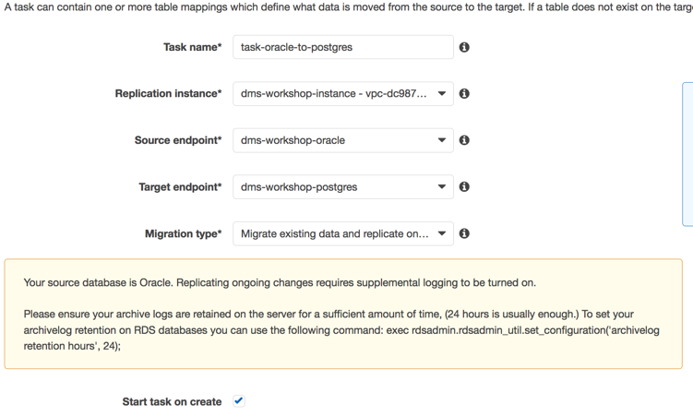

* Task Settings

|  |  |
| --- | --- |
| Target table preparation mode | Do nothing |
| Stop task after full load completes | Don't Stop |
| Include LOB columns in replication | Limited LOB Mode |
| Max LOB size (kb) | 32KB |
| Enable logging | Checked |



* Table Mappings: include all tables in DMS_SAMPLE schema

|  |  |
| --- | --- |
| Schema Name is | DMS_SAMPLE |
| Table name is like | % |
| Action | Include |

* + Click '**Add Selection Rule**'

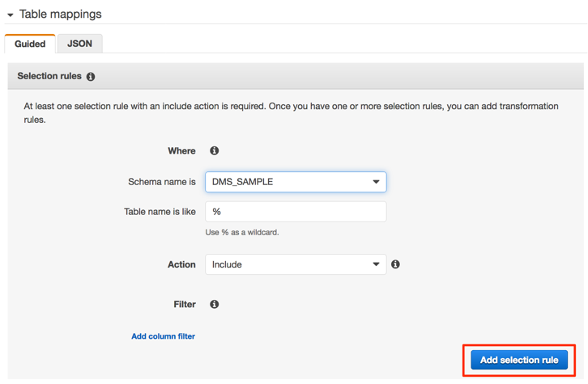

* Under 'Transformation rules' section click on 'add transformation rule' (we will add 3 rules)

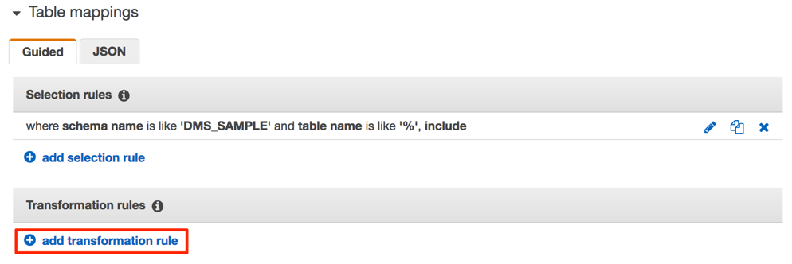

* + Rule 1:

|  |  |
| --- | --- |
| Target | Schema |
| Schema Name is | DMS_SAMPLE |
| Action | Make lowercase |

* + - Click '**Add transformation rule**'.

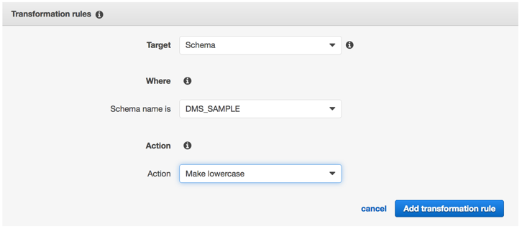

* + Rule 2:

|  |  |
| --- | --- |
| Target | Table |
| Schema Name is | DMS_SAMPLE |
| Table Name is like | % |
| Action | Make lowercase |

* + - Click 'Add transformation rule'.

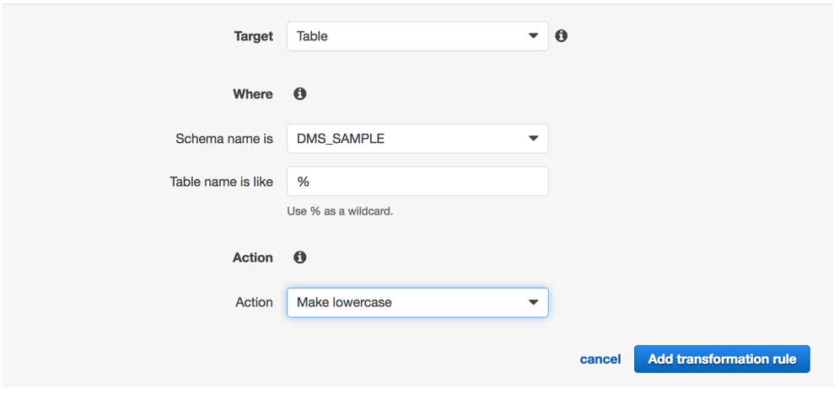

* + Rule 3:

|  |  |
| --- | --- |
| Target | Column |
| Schema Name is | DMS_SAMPLE |
| Table Name is like | % |
| Column name is like | % |
| Action | Make lowercase |

* + - Click 'Add transformation rule'.

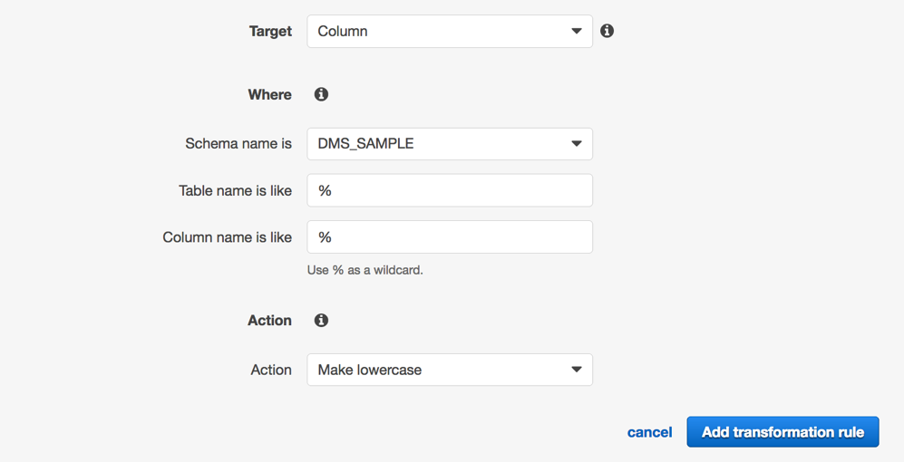

* Make sure your configuration looks like the image below.

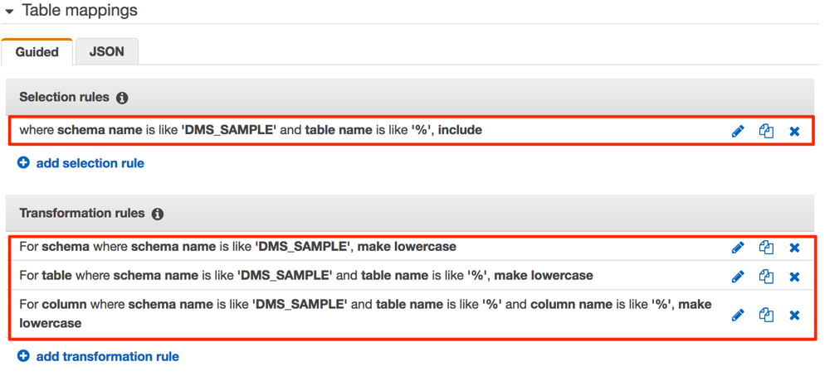

* Click on **'Create Task'** and wait for the task to get created and start running. However, shorty you will notice that the task status is ‘Error’.

Troubleshooting Initial Load

In this step, you will understand one of common errors that customers found, and how to debug the DMS task log and troubleshoot the issue. There are prerequisites of migration that you need to consider when using DMS, and we recommend you read carefully prerequisites and troubleshooting in the AWS document before you run migration tasks.

* Prerequisites of Migrating an Oracle to PostgreSQL

<http://docs.aws.amazon.com/dms/latest/sbs/CHAP_RDSOracle2PostgreSQL.Prerequisites.html>

* Troubleshooting of Migrating an Oracle to PostgreSQL

<http://docs.aws.amazon.com/dms/latest/sbs/CHAP_Oracle2PostgreSQL.Troubleshooting.html>

# CloudWatch Logs for DMS Task

Let’s stop the task, and click on the task tame in Logs tab. This will open a new window with CloudWatch Logs console for this DMS task.

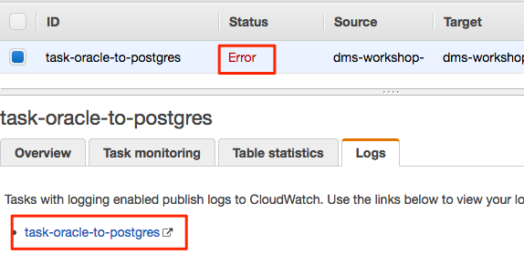

In cloud watch logs, you can filter (e.g. for last 1 week with ‘**1w**’) or display in ‘**Text**’ mode.

* Filter text with **"E:"** (with double quotes) – this will filter & show messages with log level Error

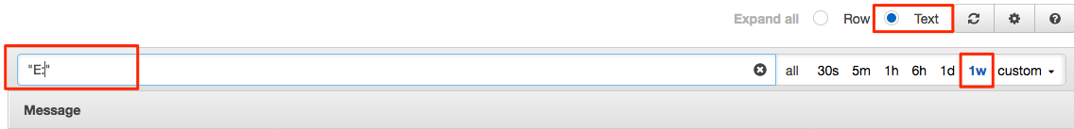

Now look through the error messages and find error messages that are causing the database migration task to fail. You will notice that there are “Supplemental logging” error messages in Coudwatch Logs.



Error: “Supplemental logging for table 'DMS_SAMPLE.MLB_DATA' is not enabled”

* The 3 tables which failed full load had supplemental logging configurational issues.
  + - MLB_DATA
    - NFL_STADIUM_DATA
    - NFL_DATA
* How do I solve this?

If a table does not have primary key or unique index on any column, you will need to enable supplemental logging on all columns in the table.

* + Login to your SQL Client of choice > connect to your **source Oracle RDS** database and run these SQL statements to enable supplemental logging on all columns;

|  |
| --- |
| ALTER TABLE DMS_SAMPLE.MLB_DATA ADD SUPPLEMENTAL LOG DATA (ALL) COLUMNS;  ALTER TABLE DMS_SAMPLE.NFL_STADIUM_DATA ADD SUPPLEMENTAL LOG DATA (ALL) COLUMNS;  ALTER TABLE DMS_SAMPLE.NFL_DATA ADD SUPPLEMENTAL LOG DATA (ALL) COLUMNS; |

At this stage, we have fixed the issues in our source database, next we need to recreate the schema in Postgres target.

* Go to Schema Conversion Tool
  + On **left** panel, right click on **DMS_SAMPLE** > **Refresh from Database**
  + On **left** panel, right click on **DMS_SAMPLE** > **Convert Schema**
  + On **right** panel, right click on **dms_sample** > **Apply to database**

Now, you now have a clean database in Postgres target.

* Let’s restart the **database migration task**:
  + Select **existing DMS task** and click **Start/Resume**. Select “Restart”, and it will try to perform an initial load from the beginning

Give it few minutes to complete the load. At this stage, the database migration task should load 100% of data from Oracle to Postgres.

* Monitoring the progress for your database migration task
  + Click on ‘Table statistics’ tab & review table level stats for your migration

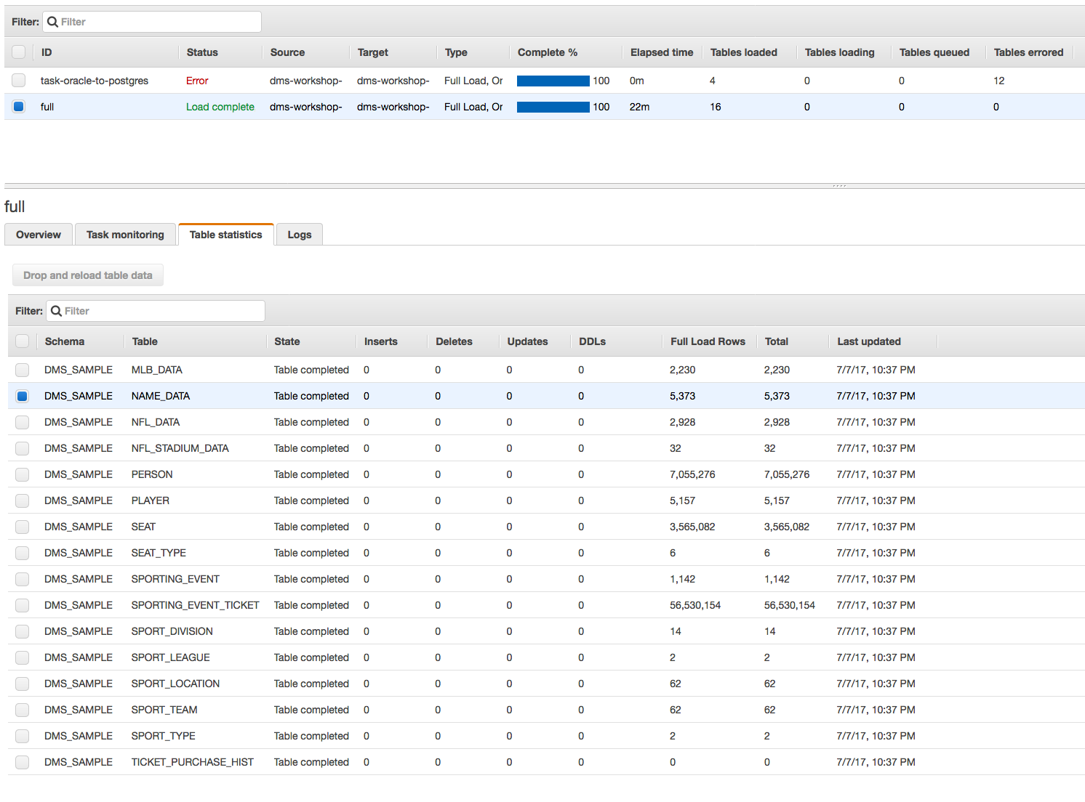

Executing transactions on the source to test CDC

In this step, you will execute a few transactions on the source to confirm your changes are migrated to target database.

* C
* Execute the following SQL statement to sell some tickets:
  + This is a stored procedure in Oracle, it will take ~ 3mins to perform 1000 transactions

|  |
| --- |
| exec ticketManagement.generateTicketActivity(0.01,1000); |

* Once the transactions are committed on source, you should see them on the target. Check the status on your DMS console > Task > Table Statistics

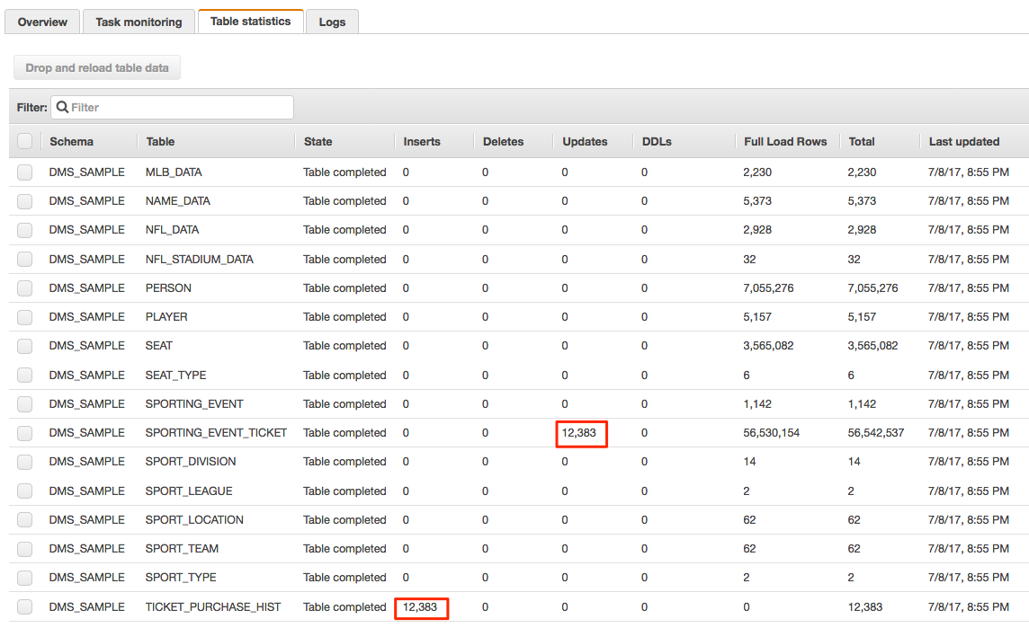



Clean Up Your Lab Environment:

DO NOT FORGET TAKE DOWN YOUR ENVIRONMENT

1. Stop and delete your database migration tasks in DMS
2. Delete the source/target endpoints in DMS
3. Delete your DMS replication instance
4. Delete the CloudFormation stack from the CloudFormation console.